Steps to push files into github Repository through local machine

Step1:first Install git using following link:

goto->https://git-scm.com/

Step2:goto git-cmd terminal and do following steps

1.goto respective directory where our files to be pushed into github

2.git init

3.git status

4.git add .

5.git commit -m "initial commit"

6.git remote add origin git@github.com:NarsimluM/FSB.git

7.git push origin master

(git@github.com: Permission denied (publickey).

fatal: Could not read from remote repository.

Please make sure you have the correct access rights

and the repository exists.)

Generate the public key as follows:

1.open git-bash

2.$ ls -al ~/.ssh

3.$ ssh-keygen -t ed25519 -C "narsimlu.kmit@gmail.com"

Generating public/private ed25519 key pair.

Enter file in which to save the key (/c/Users/Ammu/.ssh/id_ed25519):

Enter passphrase (empty for no passphrase):

Enter same passphrase again:

Your identification has been saved in /c/Users/Ammu/.ssh/id_ed25519

Your public key has been saved in /c/Users/Ammu/.ssh/id_ed25519.pub

4.$ eval "$(ssh-agent -s)"

Agent pid 959

5.$ ssh-add ~/.ssh/id_ed25519

Enter passphrase for /c/Users/Ammu/.ssh/id_ed25519:

Identity added: /c/Users/Ammu/.ssh/id_ed25519 (narsimlu.kmit@gmail.com)

Adding a new SSH key to your GitHub account

To configure your account on GitHub.com to use your new (or existing)

SSH key,you'll also need to add the key to your account.

Copy the SSH public key to your clipboard.

6.$ clip < ~/.ssh/id_ed25519.pub

# Copies the contents of the id_ed25519.pub file to your clipboard

7. In the upper-right corner of any page, click your profile photo, then click **Settings**.

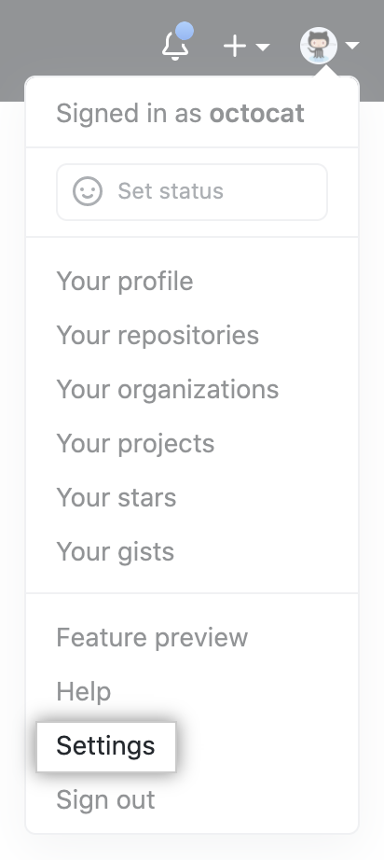

In the "Access" section of the sidebar, click

8. **SSH and GPG keys**.

9. Click **New SSH key** or **Add SSH key**.

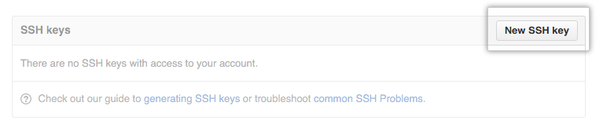

10. In the "Title" field, add a descriptive label for the new key. For example, if you're using a personal Mac, you might call this key "Home Desktop".

11. Paste your key into the "Key" field.

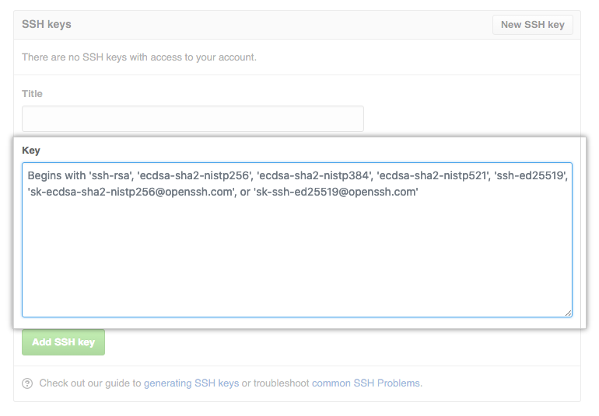

12. Click **Add SSH key**.

